Lab 4 — Cloud Security Posture Management

Objective
Use ScoutSuite and CloudQuery to inspect an AWS environment and review cloud security posture information.

Tools
- ScoutSuite — cloud security auditing tool
- CloudQuery — cloud asset inventory and querying tool
- AWS — cloud environment being assessed

Part 1: ScoutSuite

1. Check the caller identity
Check the identity used by the AWS environment before running the assessment. The original lab recommends using AWS CloudShell for this step.
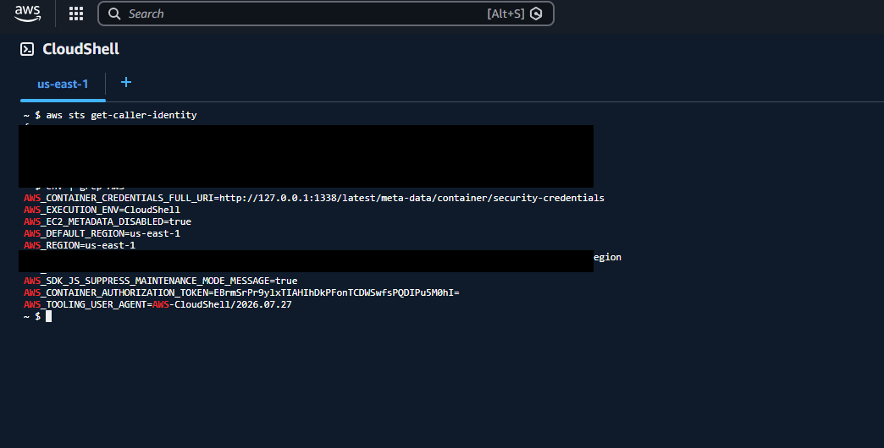
1. Check the caller identity

2. Install ScoutSuite
Install ScoutSuite using the command shown in the screenshot.
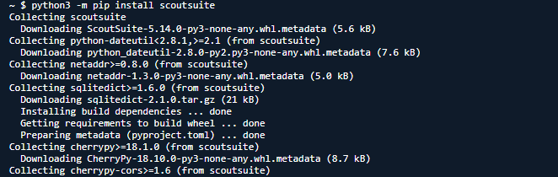
2. Install ScoutSuite

3. Wait for the scan to finish
Allow the scan to complete. The original lab notes that warnings may appear; wait for the report-generation process to finish.
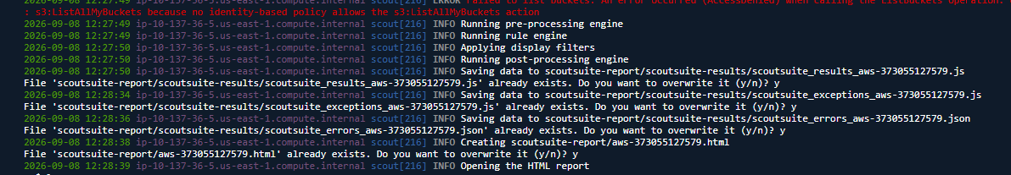
3. Wait for the scan to finish

4. Review the report
Download the report using the CloudShell interface and inspect the generated ScoutSuite report.
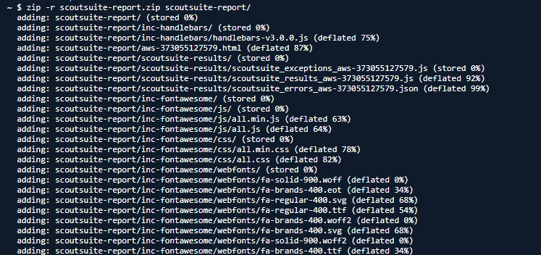
4. Review the report

Part 2: CloudQuery

1. Download and install CloudQuery
Download and install CloudQuery, following the commands shown in the screenshot.
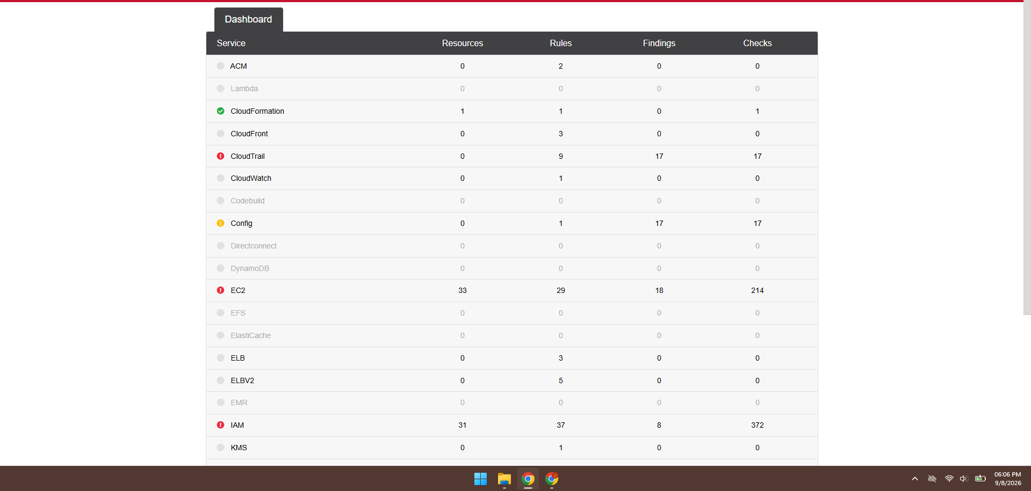
1. Download and install CloudQuery

2. Initialize CloudQuery
Initialize CloudQuery with AWS as the source and SQLite as the destination.
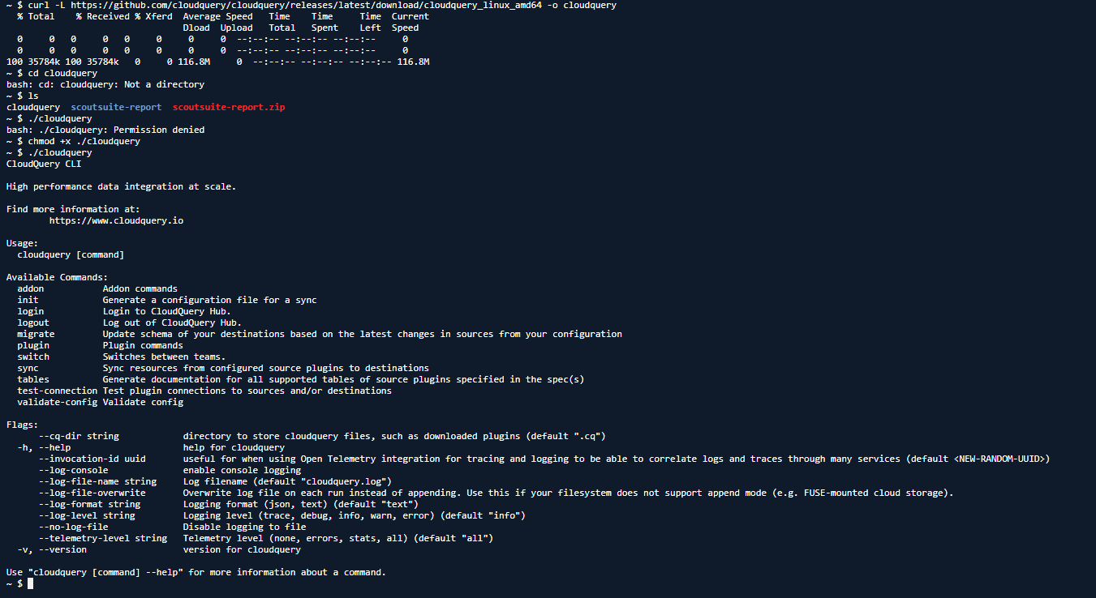
2. Initialize CloudQuery

3. Review the YAML configuration
Inspect the generated YAML configuration and verify that the source and destination match the selections made during initialization.
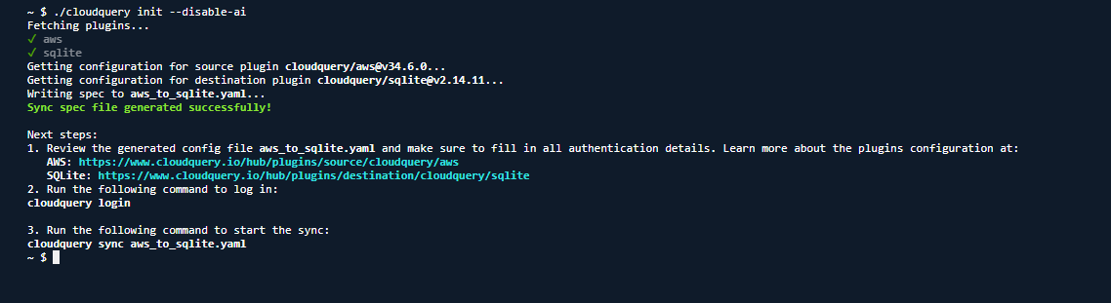
3. Review the YAML configuration

4. Authenticate with CloudQuery
Log in to CloudQuery and complete the authentication process as shown in the original lab.
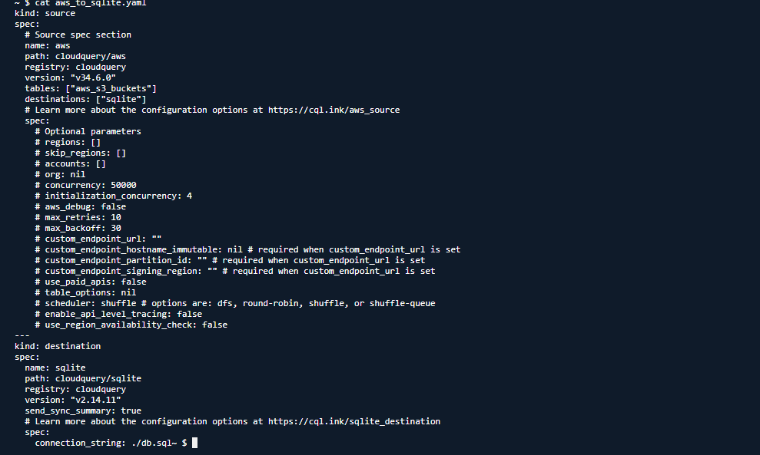
4. Authenticate with CloudQuery

5. Initialize the AI assistant for policy checks
Start the CloudQuery AI assistant and describe the intended task: inventory the AWS account and perform security-policy checks.
5. Initialize the AI assistant for policy checks

6. Update and validate the database configuration
Modify the database configuration in the YAML file as demonstrated in the screenshot, then validate the configuration.
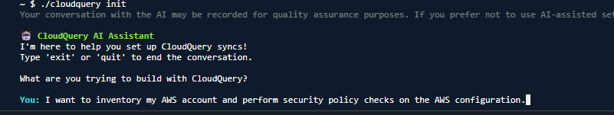
6. Update and validate the database configuration

7. Run the synchronization
Run the CloudQuery sync command using the YAML configuration file and wait for synchronization to complete.
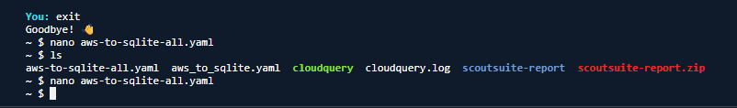
7. Run the synchronization

8. Inspect the database
Download the resulting database file and investigate its tables using SQL queries or a database browser.
8. Inspect the database

Additional Screenshots from the Original Lab
These additional screenshots were present in the source document and are retained for completeness.
Additional screenshot 13
Additional screenshot 14
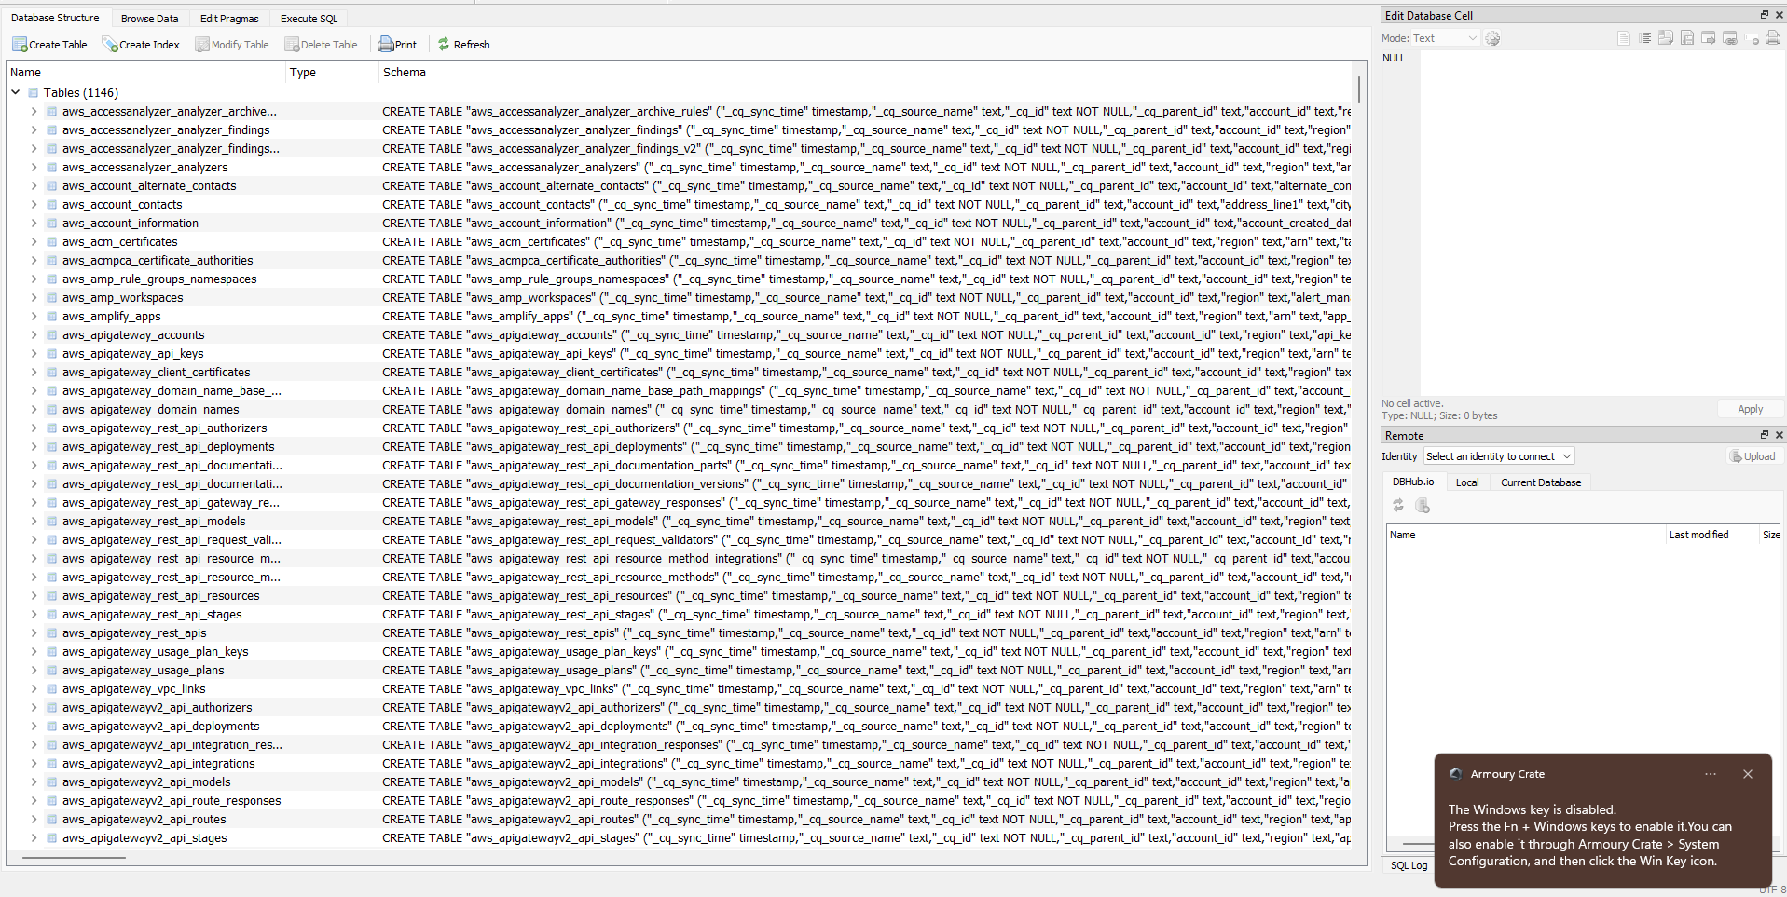
Additional screenshot 15

Security Note
Treat authentication tokens and credential-bearing URLs as secrets. Do not publish them in screenshots, configuration files, shell history, or GitHub commits. Remove account identifiers and other sensitive information before publishing.

Result
ScoutSuite was used to generate a cloud security assessment report. CloudQuery was initialized with AWS as the source and SQLite as the destination, then used to synchronize cloud inventory data for inspection.

Notes
- Results depend on the AWS account, configured permissions, tool versions, and configuration files used during the run.
- Review findings in context before making changes to an AWS environment.

